Annexure 1

Machine Learning (CSL 313)

Lab Practical Report


Faculty name: Ankita Bhalla Student name: Nishant Rajora
Roll no : 23CSU220
Semester : 6th
Group : DS-2

Department of Computer Science and Engineering NorthCap University, Gurugram‐ 122001, India Session 2024‐2025

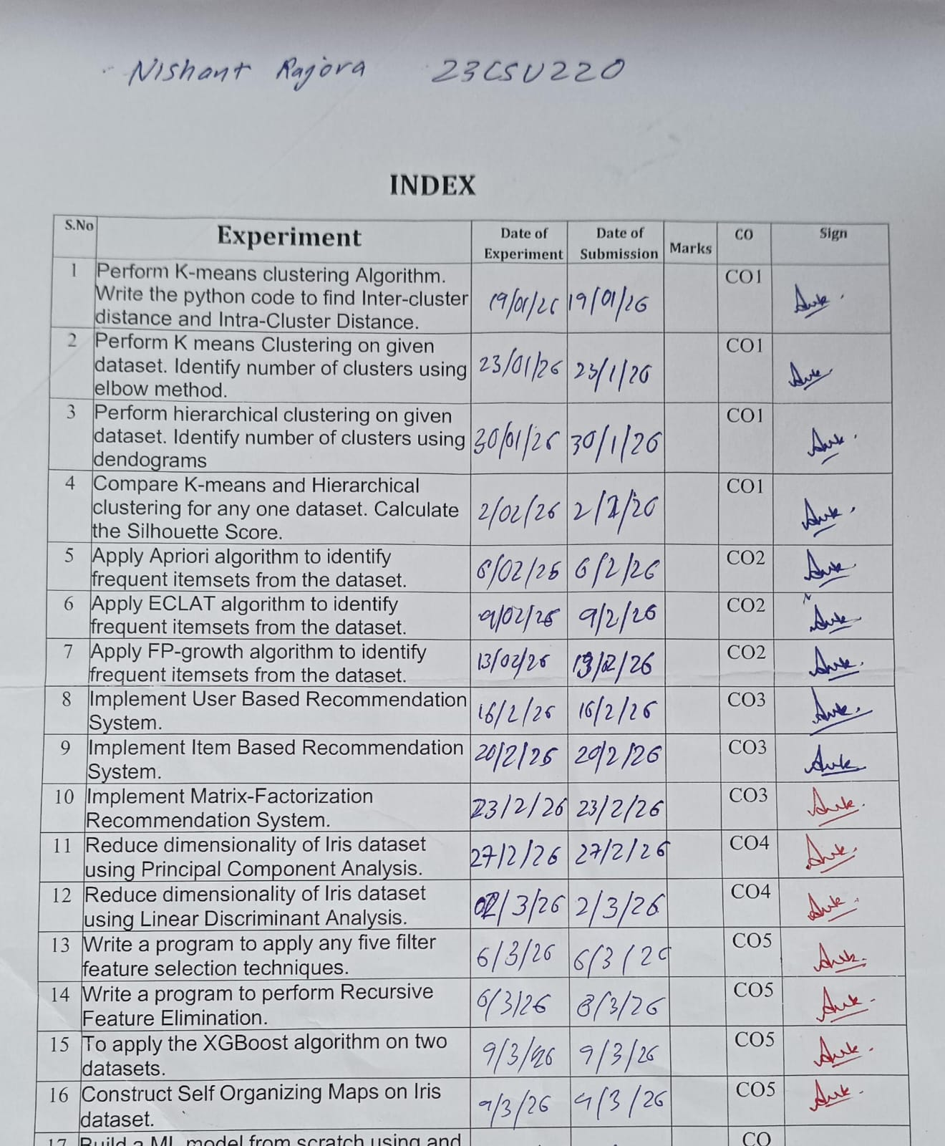

EXPERIMENT NO. 1

Student Name and Roll Number: Nishant Rajora 23csu220
Semester /Section: 6th Sem DS-A
Link to Code: https://github.com/NishantRajora/Machine-Learning
Date:
Faculty Signature:
Grade:

Objective(s):
- Understand what is unsupervised learning.
- Study about clustering and different clustering approaches.
- Implement k-means clustering for solving a real-world problem.
Outcome:

Students would be familiarized with unsupervised learning and clustering in particular.
Problem Statement:
Perform K-means clustering Algorithm. Write the python code to find Inter-cluster distance and Intra-Cluster Distance.
Background Study: K-means clustering is a method of vector quantization, originally from signal processing, that aims to partition n observations into k clusters in which each observation belongs to the cluster with the nearest mean (cluster centers or cluster centroid), serving as a prototype of the cluster.
Question Bank:
- What is the difference between supervised and unsupervised learning?
Answer: Supervised learning uses labeled data and predicts a target output. It is mainly used for classification and regression. Examples include Linear Regression and SVM. Unsupervised learning uses unlabeled data and finds hidden patterns in data. It is mainly used for clustering and association. Examples include K-Means and DBSCAN.
- What is clustering?
Answer: Clustering is an unsupervised learning technique that groups similar data points into clusters based on similarity. It is commonly used in customer segmentation, pattern recognition, and anomaly detection.
- What are the different types of clustering approaches?
Answer: The main types of clustering approaches are Partition-based (K-Means), Hierarchical (Agglomerative and Divisive), Density-based (DBSCAN), Grid-based, and Model-based clustering.
- How to find the optimal value of k in K-Means clustering?
Answer: The optimal value of k can be determined using the Elbow Method (identify the bend point in the WCSS graph), Silhouette Score (choose k with highest score), and Gap Statistic.

Student Work Area
Algorithm/Flowchart/Code/Sample Outputs

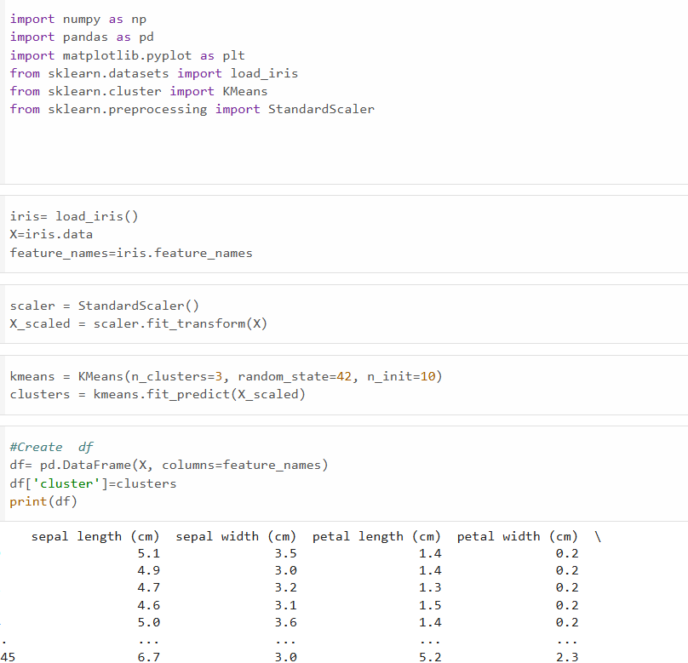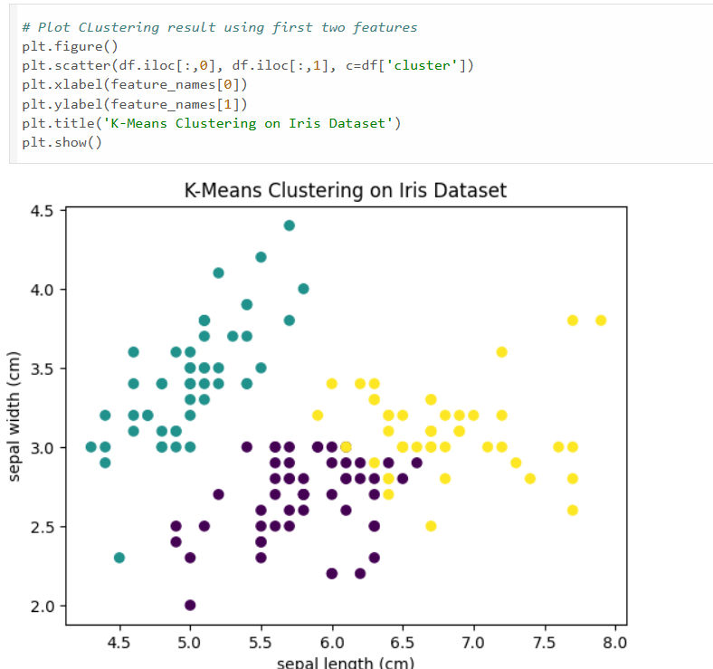
EXPERIMENT NO. 2

Student Name and Roll Number: Nishant Rajora 23csu220
Semester /Section: 6th Sem DS-A
Link to Code: https://github.com/NishantRajora/Machine-Learning
Date:
Faculty Signature:
Grade:

Objective(s):
- Understand supervised and unsupervised learning.
- Study about clustering and different clustering approaches.
- Study about how to find the number of clusters in Kmeans clustering approach
Outcome:

Students would be familiarized with unsupervised learning and K-means clustering in particular.
Problem Statement:
Perform K means Clustering on given dataset. Identify number of clusters using elbow method.
Background Study:

K-means clustering is a method of vector quantization, originally from signal processing, that aims to partition n observations into k clusters in which each observation belongs to the cluster with the nearest mean (cluster centers or cluster centroid), serving as a prototype of the cluster.
In cluster analysis, the elbow method is a heuristic used in determining the number of clusters in a data set. The method consists of plotting the explained variation as a function of the number of clusters, and picking the elbow of the curve as the number of clusters to use.
Question Bank:
- What is the difference between supervised and unsupervised learning?
Answer: Supervised learning uses labeled data and predicts a known target output. It is used for classification and regression. Examples are Linear Regression and SVM. Unsupervised learning uses unlabeled data and finds hidden patterns or groups in data. It is mainly used for clustering. Examples are K-Means and DBSCAN.
- What is K-means clustering?
Answer: K-means clustering is a partition-based unsupervised algorithm that divides data into k clusters. It works by randomly selecting k centroids, assigning data points to the nearest centroid, and updating centroids until convergence.
- What are the different types of clustering approaches?
Answer: The main types are Partition-based (K-Means), Hierarchical (Agglomerative and Divisive), Density-based (DBSCAN), Grid-based, and Model-based clustering.
- How to find the optimal value of k in K-means clustering?
Answer: The optimal value of k can be found using the Elbow Method (bend point in WCSS graph), Silhouette Score (highest score), and Gap Statistic.

Student Work Area
Algorithm/Flowchart/Code/Sample Outputs

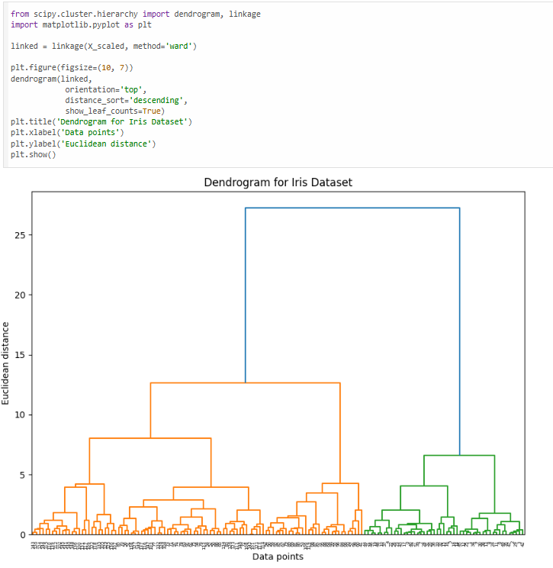
EXPERIMENT NO. 3

Student Name and Roll Number: Nishant Rajora 23csu220
Semester /Section: 6th Sem DS-A
Link to Code: https://github.com/NishantRajora/Machine-Learning
Date:
Faculty Signature:
Grade:

Objective(s):
- Understand supervised and unsupervised learning.
- Study about clustering and different clustering approaches.
- Implement both Hierarchical clustering algorithm on any one dataset.
Outcome:

Student will be familiarized with the different types of clustering algorithms.
Problem Statement:
Perform hierarchical clustering on given dataset. Identify number of clusters using dendograms
Background Study:
In data mining and statistics, hierarchical clustering (also called hierarchical cluster analysis or HCA) is a method of cluster analysis which seeks to build a hierarchy of clusters. Strategies for hierarchical clustering generally fall into two types:
- Agglomerative: This is a "bottom-up" approach: each observation starts in its own cluster, and pairs of clusters are merged as one moves up the hierarchy.
- Divisive: This is a "top-down" approach: all observations start in one cluster, and splits are performed recursively as one moves down the hierarchy.
In general, the merges and splits are determined in a greedy manner. The results of hierarchical clustering are usually presented in a dendrogram.

Question Bank:
- What is a dendrogram?
Answer: A dendrogram is a tree-like diagram used in hierarchical clustering to show how data points are merged into clusters. It represents the sequence of merges and the distance at which clusters are combined.
- What is Hierarchical Agglomerative clustering?
Answer: Hierarchical Agglomerative clustering is a bottom-up clustering method where each data point starts as its own cluster and pairs of clusters are merged step by step based on similarity until all points form a single cluster.
- What is the linkage criteria used in Hierarchical clustering?
Answer: Linkage criteria determine how the distance between two clusters is calculated. Common types are Single linkage (minimum distance), Complete linkage (maximum distance), Average linkage (average distance), and Ward’s method (minimizes variance).
- What are the different distance metrics that can be used for Hierarchical clustering?
Answer: Common distance metrics are Euclidean distance, Manhattan distance, Minkowski distance, and Cosine similarity.

Student Work Area
Algorithm/Flowchart/Code/Sample Outputs
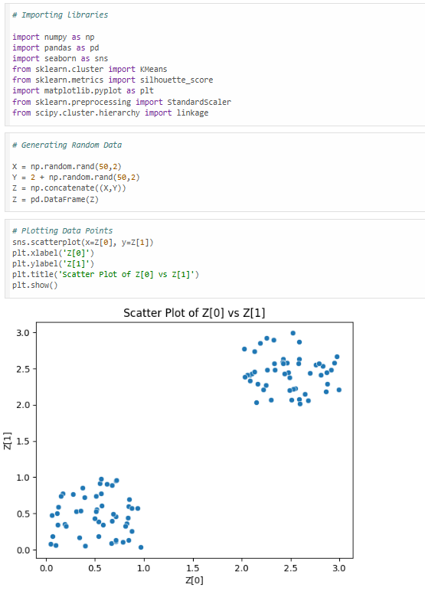
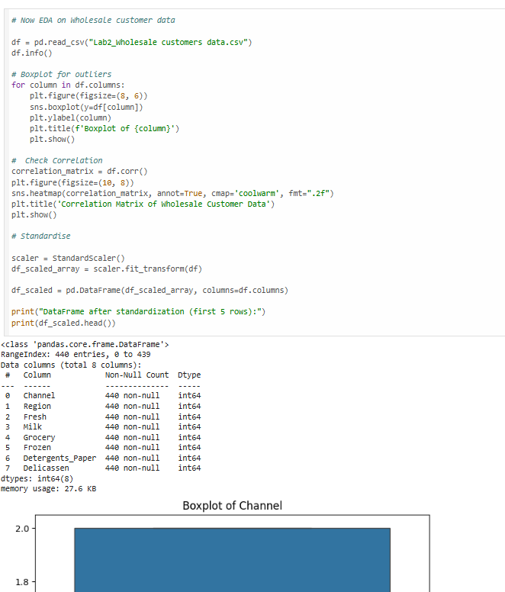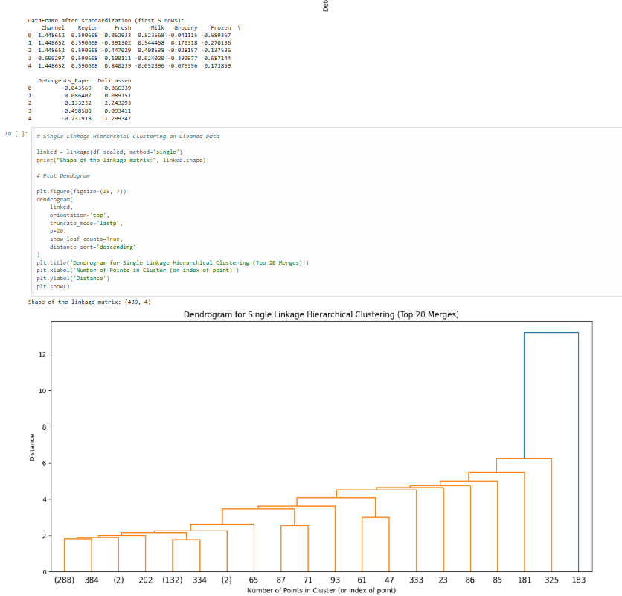
EXPERIMENT NO. 4

Student Name and Roll Number: Nishant Rajora 23csu220
Semester /Section: 6th Sem DS-A
Link to Code: https://github.com/NishantRajora/Machine-Learning
Date:
Faculty Signature:
Grade:

Objective(s):
- Understand supervised and unsupervised learning.
- Study about clustering and different clustering approaches.
- Implement both Hierarchical and K-means clustering algorithm on any one dataset.
- Compare and contrast Hierarchical and K-means clustering algorithm.
Outcome:

Students will be familiarized with clustering algorithms.
Problem Statement:
Compare K-means and Hierarchical clustering for any one dataset. Calculate the Silhouette Score.
Background Study:

K-means is method of cluster analysis using a pre-specified no. of clusters. It requires advance knowledge of ‘K’. Hierarchical clustering also known as hierarchical cluster analysis (HCA) is also a method of cluster analysis which seeks to build a hierarchy of clusters without having fixed number of clusters. In hierarchical clustering one can stop at any number of clusters and find appropriate clusters by interpreting the dendrogram.
Question Bank:
- What are the advantages and disadvantages of K-means vs hierarchical clustering?
Answer: K-means is simple, fast, and works well for large datasets, but it requires choosing k in advance and is sensitive to initial centroids and outliers. It works best for spherical clusters. Hierarchical clustering does not require specifying k initially and produces a dendrogram for better visualization, but it is computationally expensive and not suitable for very large datasets. It is also difficult to undo merges once done.
- Compare the time complexities of K-means vs hierarchical clustering.
Answer: The time complexity of K-means is approximately O(n × k × t), where n is number of data points, k is number of clusters, and t is number of iterations. It is relatively efficient for large datasets. Hierarchical clustering has a time complexity of about O(n²) or O(n³) depending on implementation, making it slower and less suitable for large datasets.

Student Work Area
Algorithm/Flowchart/Code/Sample Outputs

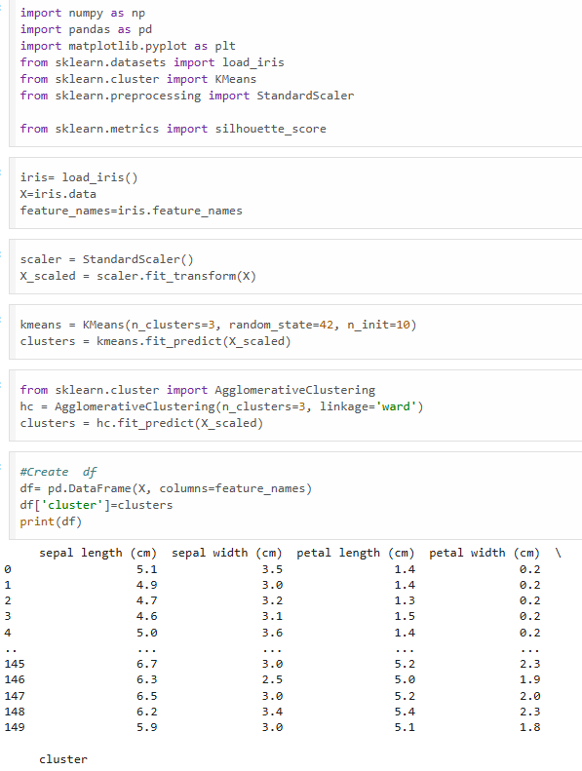
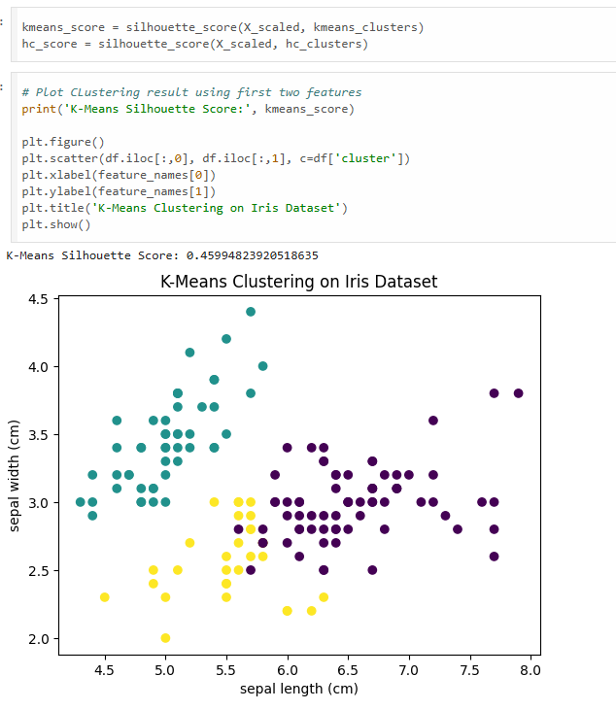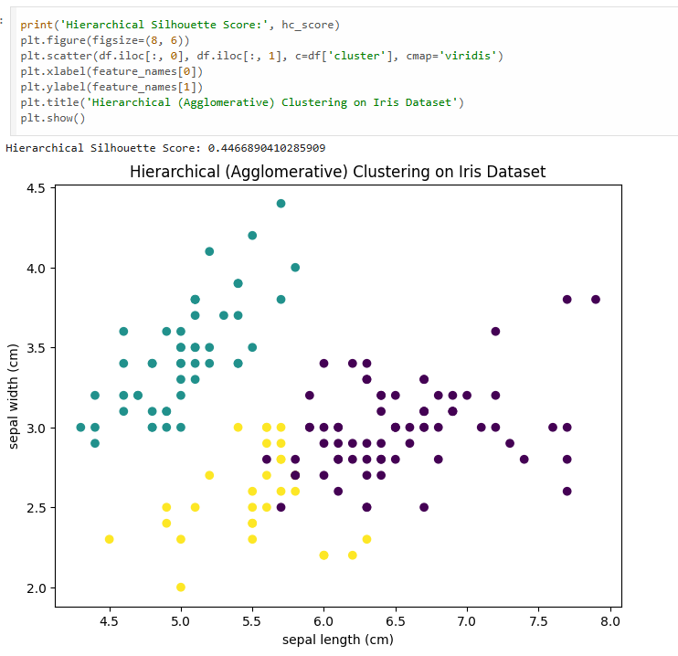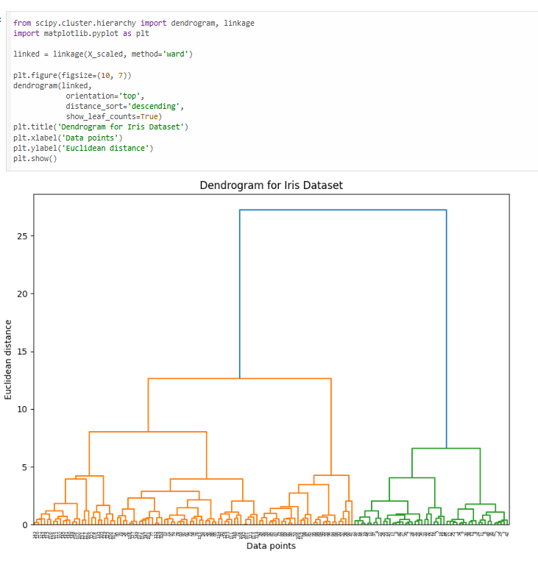
EXPERIMENT NO. 5

Student Name and Roll Number: Nishant Rajora 23csu220
Semester /Section: 6th Sem DS-A
Link to Code: https://github.com/NishantRajora/Machine-Learning
Date:
Faculty Signature:
Grade:

Objective(s):
- Understand and study Association Rule Mining.
- Study the Apriori property and Apriori Rule in Association Rule Mining.
- Implement the Apriori algorithm in Association Rule Mining.
Outcome:

Students will be familiarized with Association Rule Mining.
Problem Statement:
Apply Apriori algorithm to identify frequent itemsets from the bakery dataset.
Background Study:

Apriori is an algorithm for frequent item set mining and association rule learning over relational databases. It proceeds by identifying the frequent individual items in the database and extending them to larger and larger item sets as long as those item sets appear sufficiently often in the database.
Question Bank:
- What is Association Rule Mining?
Answer: Association Rule Mining is a data mining technique used to discover interesting relationships or patterns between items in large datasets. It identifies rules like “If A occurs, then B also occurs” using measures such as support, confidence, and lift.
- What is the Apriori property?
Answer: The Apriori property states that if an itemset is frequent, then all of its subsets must also be frequent. It is used to reduce the search space in the Apriori algorithm by eliminating infrequent itemsets early.
- Does Association Rule Mining fall under supervised or unsupervised ML?
Answer: Association Rule Mining falls under unsupervised learning because it works on unlabeled data and discovers hidden patterns without a target variable.
- List the applications of Association Rule Mining.
Answer: Applications include market basket analysis, recommendation systems, cross-selling strategies, inventory management, web usage mining, and fraud detection.

Student Work Area
Algorithm/Flowchart/Code/Sample Outputs
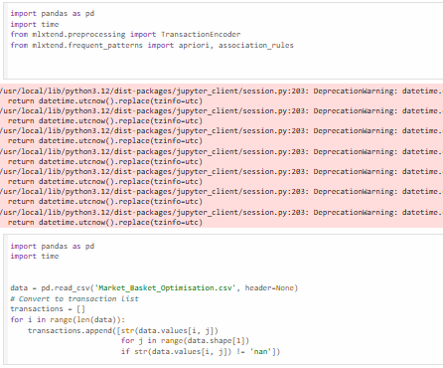

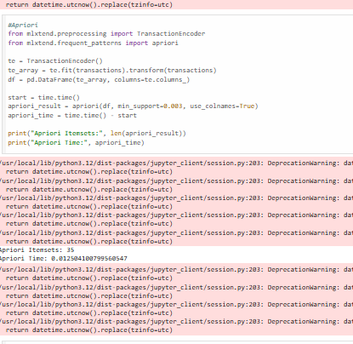

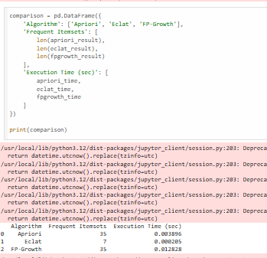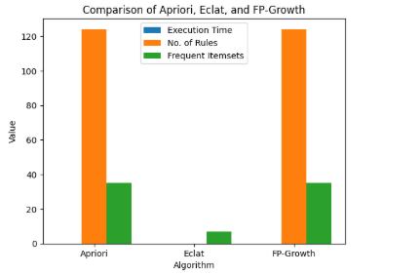
EXPERIMENT NO. 6

Student Name and Roll Number: Nishant Rajora 23csu220
Semester /Section: 6th Sem DS-A
Link to Code: https://github.com/NishantRajora/Machine-Learning
Date:
Faculty Signature:
Grade:

Objective(s):
- Understand and study Association Rule Mining.
- Study the ECLAT algorithm in Association Rule Mining.
- Implement the ECLAT algorithm in Association Rule Mining.
Outcome:

Students will be familiarized with Association Rule Mining.
Problem Statement:
Apply ECLAT algorithm to identify frequent itemsets from the bakery dataset.
Background Study:

The ECLAT algorithm stands for Equivalence Class Clustering and bottom-up Lattice Traversal. It is one of the popular methods of Association Rule mining. It is a more efficient and scalable version of the Apriori algorithm.
Question Bank:
- What is the ECLAT algorithm?
Answer: ECLAT (Equivalence Class Clustering and bottom-up Lattice Traversal) is a frequent itemset mining algorithm used in Association Rule Mining. It uses a vertical data format (transaction ID sets) and finds frequent itemsets by intersecting transaction ID lists instead of generating candidate sets like Apriori.
- What are the advantages of ECLAT algorithm over Apriori?
Answer: ECLAT is faster than Apriori for large datasets because it uses TID list intersection instead of repeated database scanning. It requires fewer scans of the database and is more memory efficient for dense datasets. It also reduces candidate generation compared to Apriori.

Student Work Area
Algorithm/Flowchart/Code/Sample Outputs


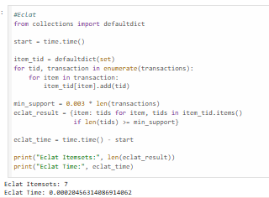
EXPERIMENT NO. 7

Student Name and Roll Number: Nishant Rajora 23csu220
Semester /Section: 6th Sem DS-A
Link to Code: https://github.com/NishantRajora/Machine-Learning
Date:
Faculty Signature:
Grade:

Objective(s):
- Understand and study Association Rule Mining.
- Study the FP-growth algorithm in Association Rule Mining.
- Implement the FP-growth algorithm in Association Rule Mining.
Outcome:

Students will be familiarized with Association Rule Mining.
Problem Statement:
Apply FP-growth algorithm to identify frequent itemsets from the bakery dataset.
Background Study:

FP Growth Algorithm (Frequent pattern growth). FP growth algorithm is an improvement of Apriori algorithm. FP growth algorithm used for finding frequent itemset in a transaction database without candidate generation. FP growth represents frequent items in frequent pattern trees or FP-tree.
Question Bank:
- What is a FP-tree?
Answer: An FP-tree (Frequent Pattern Tree) is a compact tree structure used to store frequent itemsets in a database. It compresses the dataset by storing common prefixes of transactions and avoids generating large candidate sets.
- What is the FP-growth algorithm?
Answer: FP-growth (Frequent Pattern Growth) is a frequent itemset mining algorithm that uses an FP-tree to mine patterns without generating candidate itemsets. It builds the FP-tree first and then extracts frequent patterns using a divide-and-conquer approach.
- List out the advantages and disadvantages of FP-growth algorithm.
Answer: Advantages: It is faster than Apriori, does not generate candidate sets, and requires fewer database scans. It works well for large and dense datasets. Disadvantages: FP-tree construction can be complex, and it may require high memory for very large datasets.
- Compare and contrast Apriori, ECLAT and FP-Growth algorithm.
Answer: Apriori uses horizontal data format and generates candidate itemsets with multiple database scans, making it slower. ECLAT uses vertical data format with TID list intersections and is faster than Apriori for dense data. FP-Growth uses a tree structure and does not generate candidate sets, making it generally faster and more efficient than both Apriori and ECLAT for large datasets.

Student Work Area
Algorithm/Flowchart/Code/Sample Output


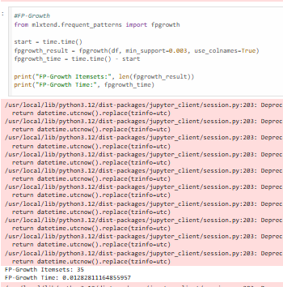
EXPERIMENT NO. 08

Student Name and Roll Number: Nishant Rajora 23csu220
Semester /Section: 6th Sem DS-A
Link to Code: https://github.com/NishantRajora/Machine-Learning
Date:
Faculty Signature:
Grade:

Objective(s):
- Understand and study Recommendation Learning.
- Study User Based Recommendation System.
Outcome:

Students will be familiarized with User Based Recommendation System.
Problem Statement:

Implement User Based Recommendation System.
Background Study:
Recommender systems are information filtering systems that help deal with the problem of information overload by filtering and segregating information and creating fragments out of large amounts of dynamically generated information according to user’s preferences, interests, or observed behavior about a particular item or items.
User-Based Collaborative Filtering is a technique used to predict the items that a user might like on the basis of ratings given to that item by the other users who have similar taste with that of the target user.
Question Bank:
- What is Recommendation System?
Answer: A Recommendation System is a machine learning system that suggests relevant items to users based on their preferences, behavior, or past interactions. It is widely used in e-commerce, Netflix, Amazon, and Spotify to recommend products, movies, or songs.
- Illustrate User Based Recommendation System.
Answer: User-Based Recommendation System is a type of collaborative filtering method. It works by finding users with similar preferences and recommending items liked by similar users. For example, if User A and User B have similar movie ratings, and User A likes a new movie, that movie will be recommended to User B.

Student Work Area
Algorithm/Flowchart/Code/Sample Outputs

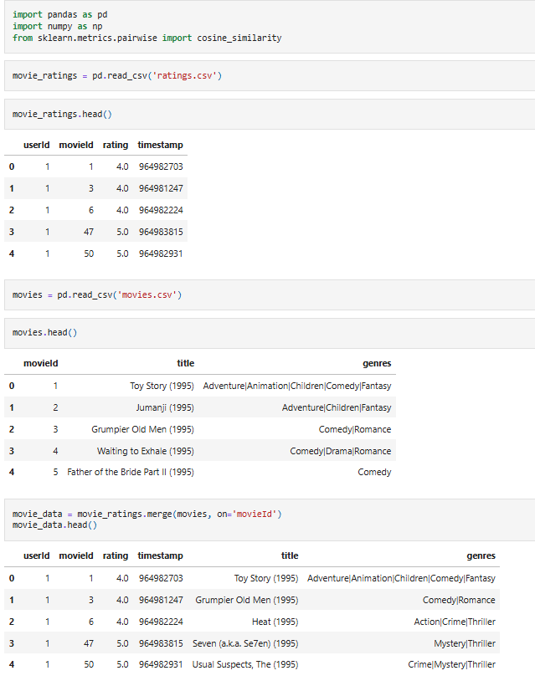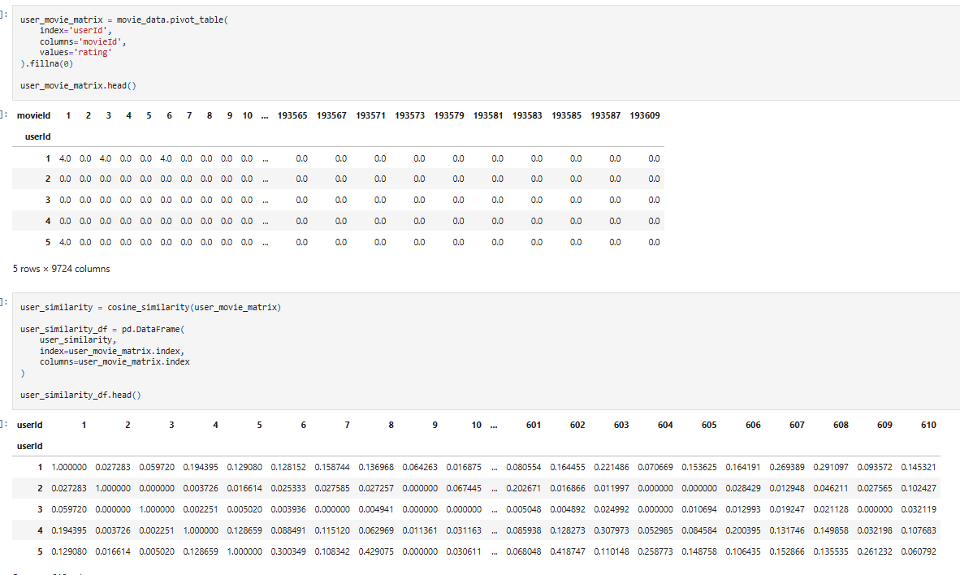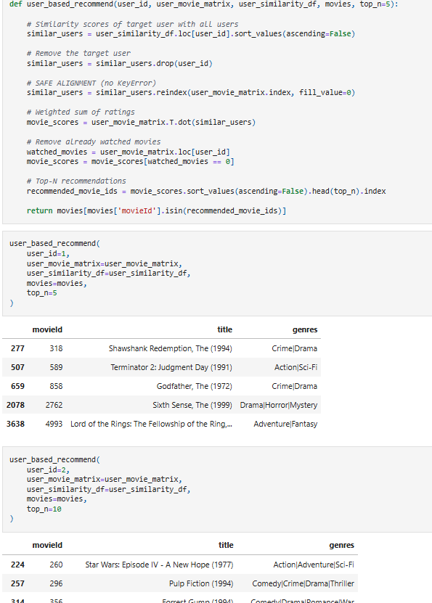
EXPERIMENT NO. 09

Student Name and Roll Number: Nishant Rajora 23csu220
Semester /Section: 6th Sem DS-A
Link to Code: https://github.com/NishantRajora/Machine-Learning
Date:
Faculty Signature:
Grade:

Objective(s):
- Understand and study Recommendation System.
- Introduction to the Item Based Recommendation System.
Outcome:

Students will be familiarized with Item Based Recommendation System.
Problem Statement:

Implement Item Based Recommendation System.
Background Study:
Item-item collaborative filtering, or item-based, or item-to-item, is a form of collaborative filtering for recommender systems based on the similarity between items calculated using people's ratings of those items.
Question Bank:
- What is Recommendation System?
Answer: A Recommendation System is a machine learning system that suggests relevant items to users based on their preferences, past behavior, or interactions. It is commonly used in platforms like Amazon, Netflix, and Spotify to recommend products, movies, or songs.

- Illustrate Item Based Recommendation System.
Answer: Item-Based Recommendation System is a type of collaborative filtering method that recommends items similar to the ones a user has already liked or purchased. It calculates similarity between items instead of users. For example, if a user buys a laptop, the system may recommend a laptop bag or mouse because these items are frequently bought together.

Student Work Area
Algorithm/Flowchart/Code/Sample Outputs


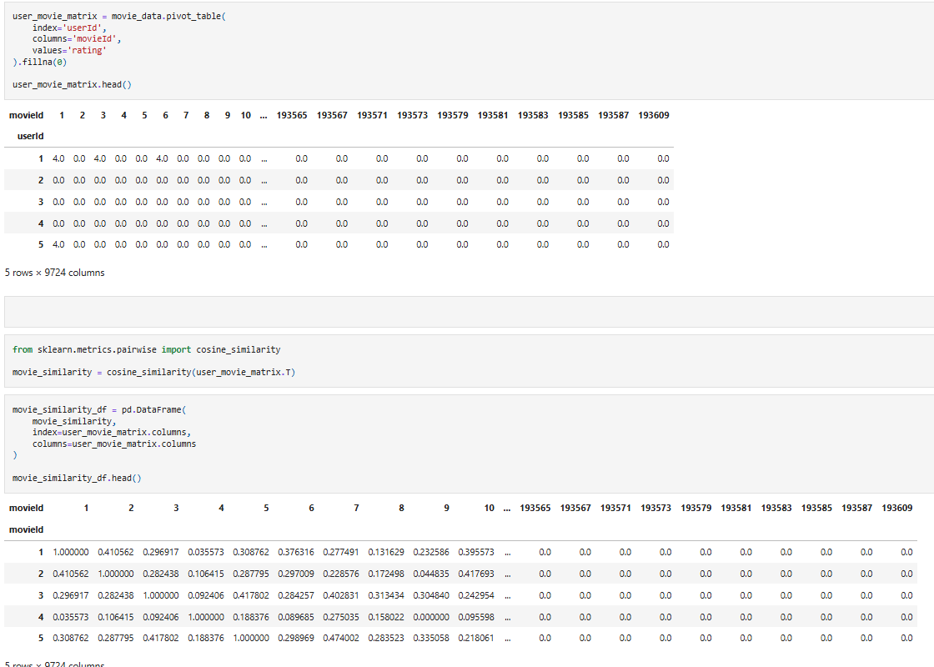
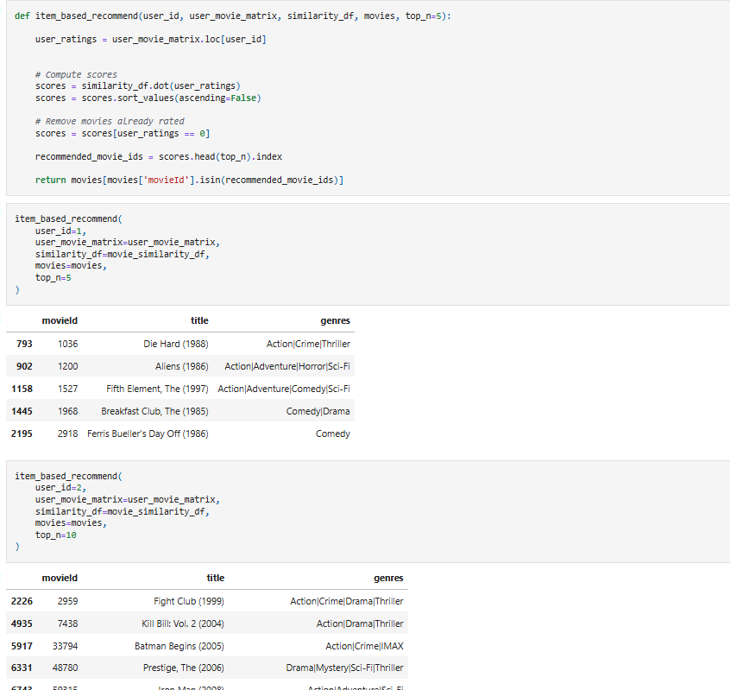
EXPERIMENT NO. 10

Student Name and Roll Number: Nishant Rajora 23csu220
Semester /Section: 6th Sem DS-A
Link to Code: https://github.com/NishantRajora/Machine-Learning
Date:
Faculty Signature:
Grade:

Objective(s):
- Understand and study Recommendation System.
- Introduction to the Matrix-Factorization Recommendation System.
Outcome:

Students will be familiarized with Matrix-Factorization Recommendation System.
Problem Statement:
Implement Matrix-Factorization Recommendation System.
Background Study:
Matrix factorization is a way to generate latent features when multiplying two different kinds of entities. Collaborative filtering is the application of matrix factorization to identify the relationship between items’ and users’ entities
Question Bank:
- What is Matrix-Factorization Recommendation System?
Answer: Matrix-Factorization Recommendation System is a collaborative filtering technique that decomposes the user–item interaction matrix into two lower-dimensional matrices, one representing users and the other representing items. It identifies latent factors (hidden features) that explain user preferences and item characteristics. The predicted rating is obtained by multiplying the user and item factor matrices. It is widely used in systems like Netflix for accurate recommendations.

Student Work Area
Algorithm/Flowchart/Code/Sample Outputs

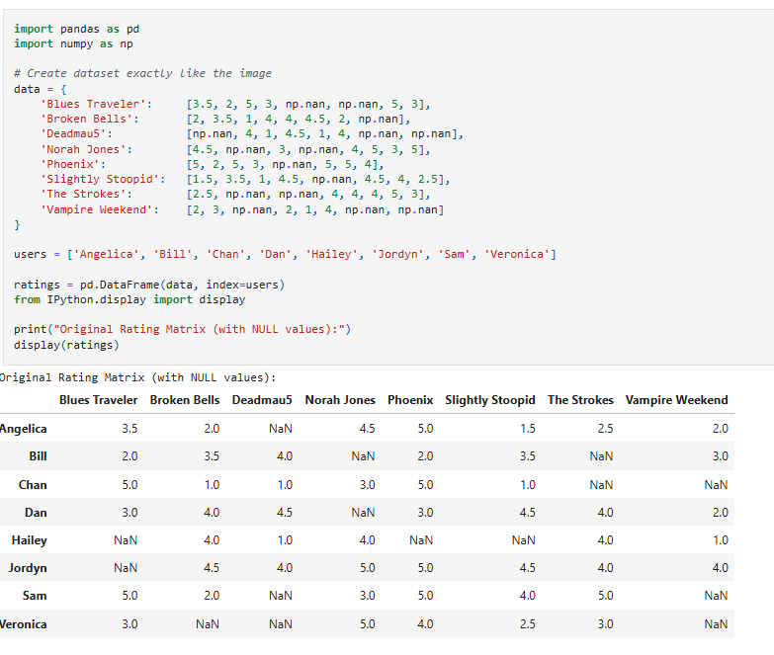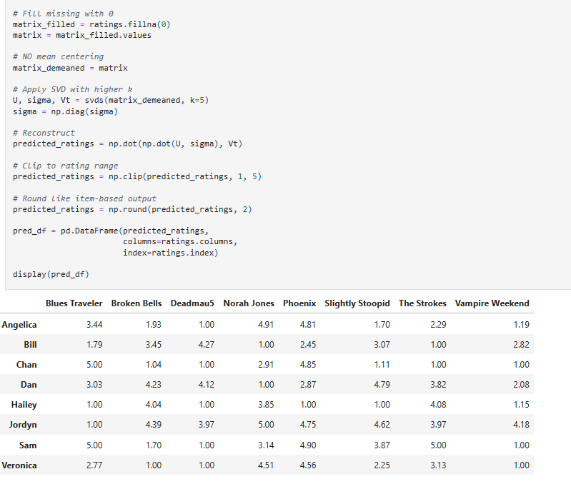
EXPERIMENT NO. 11

Student Name and Roll Number: Nishant Rajora 23csu220
Semester /Section: 6th Sem DS-A
Link to Code: https://github.com/NishantRajora/Machine-Learning
Date:
Faculty Signature:
Grade:

Objective(s):
- Study Dimensionality Reduction.
- Understand the basic principle behind Principal Component Analysis.
Outcome:

Students will be familiarized with Dimensionality Reduction especially Principal Component Analysis (PCA).
Problem Statement:
Reduce dimensionality of Iris dataset using Principal Component Analysis.
Background Study:

Principal component analysis is a statistical technique that is used to analyze the interrelationships among a large number of variables and to explain these variables in terms of a smaller number of variables, called principal components, with a minimum loss of information.
Question Bank:
- What is dimensionality reduction?
Answer: Dimensionality reduction is a technique used to reduce the number of input features in a dataset while preserving important information. It helps in reducing computation time, avoiding overfitting, and improving model performance. Examples include PCA and LDA.
- Differentiate between Feature Selection, Feature Engineering and Dimensionality Reduction.
Answer: Feature Selection involves selecting the most important features from the existing dataset without changing them. Feature Engineering involves creating new features from existing data to improve model performance. Dimensionality Reduction transforms the original features into a smaller set of new features while preserving maximum information, such as in PCA.
- What are principal components?
Answer: Principal components are new transformed variables created in PCA. They are linear combinations of original features and are arranged in order of maximum variance. The first principal component captures the highest variance, followed by the second, and so on.

Student Work Area
Algorithm/Flowchart/Code/Sample Outputs

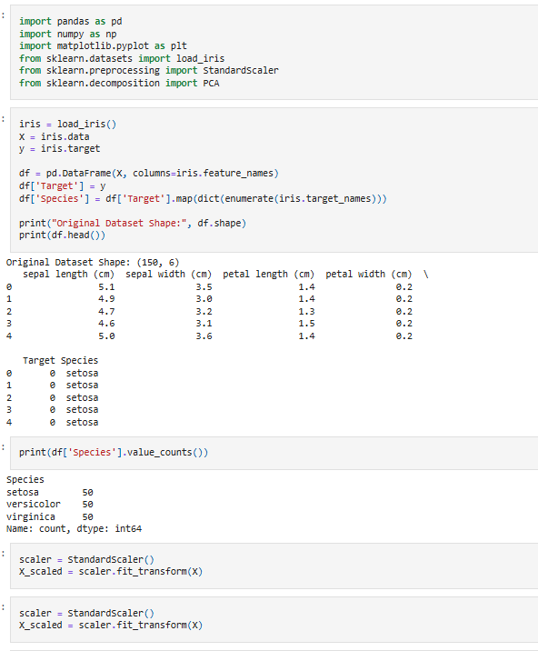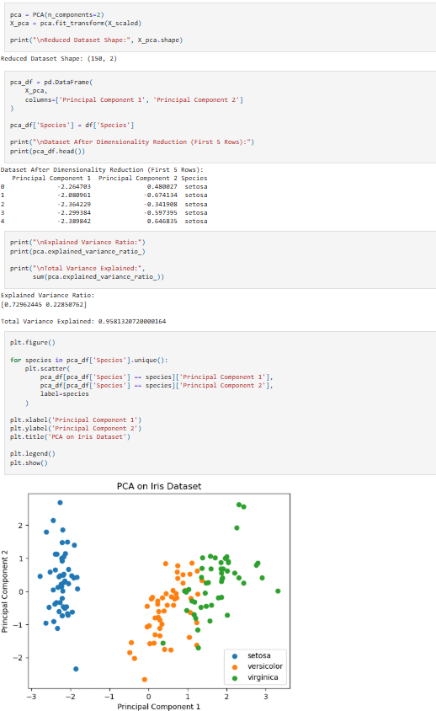
EXPERIMENT NO. 12

Student Name and Roll Number: Nishant Rajora 23csu220
Semester /Section: 6th Sem DS-A
Link to Code: https://github.com/NishantRajora/Machine-Learning
Date:
Faculty Signature:
Grade:

Objective(s):
- Study Dimensionality Reduction.
- Understand the basic principle behind Linear Discriminant Analysis.
Outcome:

Students will be familiarized with Dimensionality Reduction especially Linear Discriminant Analysis (LDA).
Problem Statement:
Reduce dimensionality of Iris dataset using Linear Discriminant Analysis.
Background Study:

Linear Discriminant Analysis or Normal Discriminant Analysis or Discriminant Function Analysis is a dimensionality reduction technique which is commonly used for the supervised classification problems. It is used for modeling differences in groups i.e., separating two or more classes. It is used to project the features in higher dimension space into a lower dimension space.
Question Bank:
- What is dimensionality reduction?
Answer: Dimensionality reduction is a technique used to reduce the number of features in a dataset while retaining important information. It helps reduce computational cost, remove noise, and prevent overfitting. Examples include PCA and LDA.
- Compare and contrast PCA and LDA for dimensionality reduction.
Answer: PCA is an unsupervised technique that reduces dimensions by maximizing variance without considering class labels. LDA is a supervised technique that reduces dimensions by maximizing class separability using labeled data. PCA focuses on variance, while LDA focuses on discrimination between classes.
- What are the QDA, FDA and RDA extensions to LDA?
Answer: QDA (Quadratic Discriminant Analysis) is an extension of LDA that allows different covariance matrices for each class, resulting in quadratic decision boundaries. FDA (Fisher Discriminant Analysis) is another name for LDA based on Fisher’s criterion of maximizing class separation. RDA (Regularized Discriminant Analysis) is a hybrid of LDA and QDA that adds regularization to improve performance when data is limited.
- List the applications of LDA.
Answer: Applications of LDA include face recognition, text classification, medical diagnosis, speech recognition, and fraud detection.

Student Work Area
Algorithm/Flowchart/Code/Sample Outputs

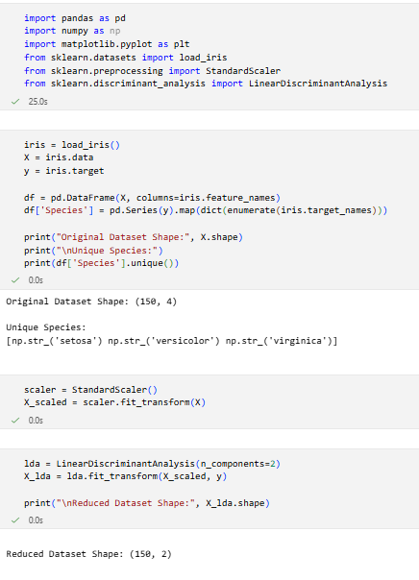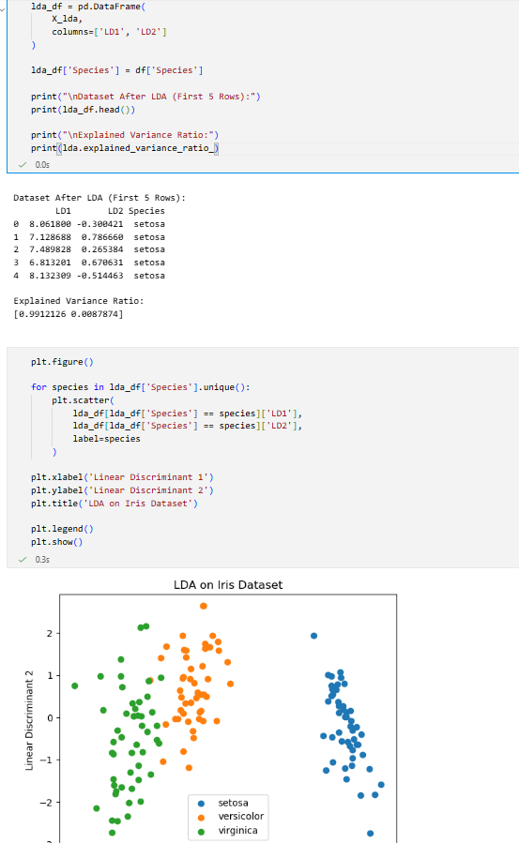
EXPERIMENT NO. 13

Student Name and Roll Number: Nishant Rajora 23csu220
Semester /Section: 6th Sem DS-A
Link to Code: https://github.com/NishantRajora/Machine-Learning
Date:
Faculty Signature:
Grade:

Objective(s):
- To understand the importance of feature selection
- To differentiate between different types of feature selection.
- Build a model using feature selection techniques.
Outcome:
Students will be familiarized with model building using feature selection techniques and optimization.
Problem Statement:

Write a program to apply any five filter feature selection techniques.
Background Study:

Feature selection is the process of reducing the number of input variables when developing a predictive model. It is desirable to reduce the number of input variables to both reduce the computational cost of modeling and, in some cases, to improve the performance of the model.
Question Bank:
- Difference between Feature Selection and Dimensionality Reduction
Feature Selection selects the most relevant features from the original dataset without modifying them. It removes unnecessary or redundant features.
Dimensionality Reduction reduces the number of features by transforming the original features into a smaller set of new features while preserving important information.
- Advantages of Wrapper Methods over Filter Methods
Wrapper methods usually provide better accuracy because they evaluate feature subsets using a machine learning model. They also consider interactions between features and select the best feature subset for a specific algorithm.
- Regularization Methods for Feature Selection
Regularization is a technique used to prevent overfitting by adding a penalty term to the loss function. L1 regularization (Lasso) can make some coefficients zero and remove unimportant features. L2 regularization (Ridge) reduces coefficient values but does not remove features. Elastic Net combines both L1 and L2 regularization.
- Embedded Feature Selection Methods
Embedded methods perform feature selection during the model training process. The algorithm itself identifies and selects the most important features. Examples include Decision Trees, Random Forest, and Lasso Regression.

Student Work Area
Algorithm/Flowchart/Code/Sample Outputs

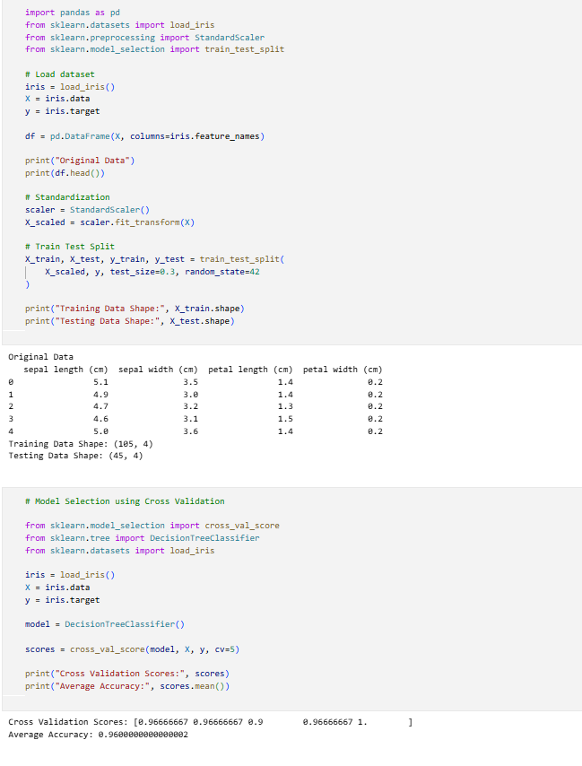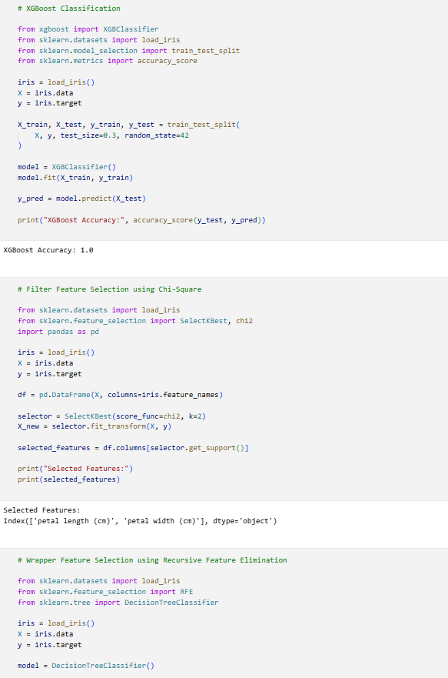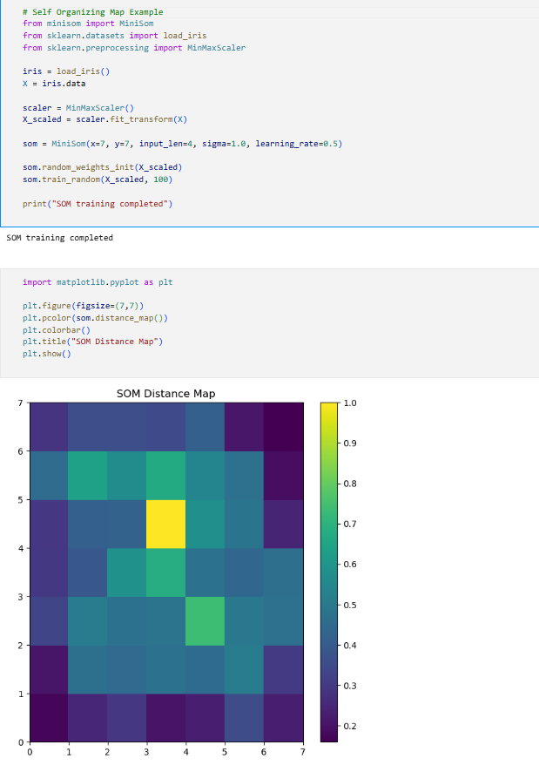
EXPERIMENT NO. 14

Student Name and Roll Number: Nishant Rajora 23csu220
Semester /Section: 6th Sem DS-A
Link to Code: https://github.com/NishantRajora/Machine-Learning
Date:
Faculty Signature:
Grade:

Objective(s):
- To understand the importance of feature selection
- To differentiate between different types of feature selection.
- To understand the importance of Hybrid Feature Selection Approaches.
- Build a model using feature selection techniques.
Outcome:
Students will be familiarized with model building using feature selection techniques and optimization.
Problem Statement:

Write a program to perform Recursive Feature Elimination.
Background Study: Recursive Feature Elimination (RFE) is popular feature selection method because it is easy to configure and use and because it is effective at selecting those features (columns) in a training dataset that are more or most relevant in predicting the target variable. There are two important configuration options when using RFE: the choice in the number of features to select and the choice of the algorithm used to help choose features. Both of these hyperparameters can be explored, although the performance of the method is not strongly dependent on these
hyperparameters being configured well.

Question Bank:
- What is Recursive Feature Elimination?
Recursive Feature Elimination (RFE) is a feature selection technique that repeatedly builds a model and removes the least important feature at each step. This process continues until the desired number of features is reached. It helps in selecting the most important features for improving model performance.
- What are Hybrid Feature Selection Techniques?
Hybrid feature selection techniques combine two or more feature selection methods, usually filter and wrapper methods, to improve the efficiency and accuracy of feature selection. First, filter methods reduce the number of features, and then wrapper methods select the best subset of features.
- Difference between Recursive Feature Elimination and Step Backward Feature Selection
Recursive Feature Elimination removes the least important feature based on the model’s importance score and repeats the process until the required number of features remains.
Step Backward Feature Selection starts with all features and removes one feature at a time based on model performance, selecting the subset that gives the best result.

Student Work Area
Algorithm/Flowchart/Code/Sample Outputs

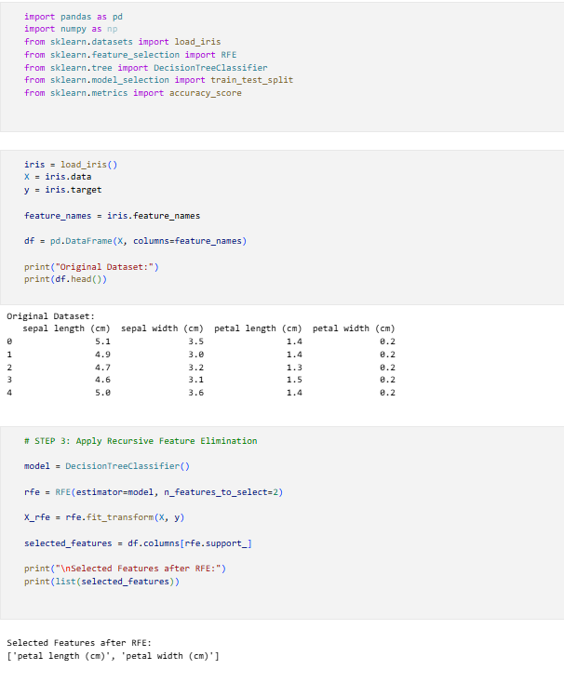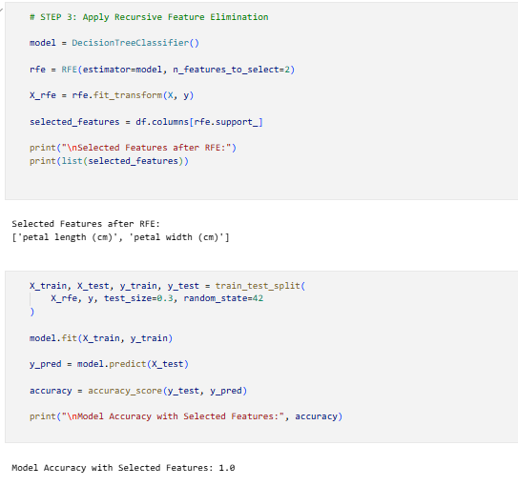

EXPERIMENT NO. 15

Student Name and Roll Number: Nishant Rajora 23csu220
Semester /Section: 6th Sem DS-A
Link to Code: https://github.com/NishantRajora/Machine-Learning
Date:
Faculty Signature:
Grade:

Objective(s):
- To study Ensemble ML algorithms.
- To build an efficient model using Ensemble Machine Learning algorithms.
- To understand and implement boosting.
Outcome:

Students will be able to understand how to build a highly efficient ML model (with high performance), faster.
Problem Statement:
To apply the XGBoost algorithm on two datasets.
Background Study: XGBoost stands for “Extreme Gradient Boosting”. XGBoost is a decision-tree- based ensemble Machine Learning algorithm that uses a gradient boosting framework. XGBoost is an optimized distributed gradient boosting library designed to be highly efficient, flexible and portable. It implements Machine Learning algorithms under the Gradient Boosting framework. It
provides a parallel tree boosting to solve many data science problems in a fast and accurate way."
Question Bank:
- What are Ensemble ML algorithms? What is their advantage?
Ensemble Machine Learning algorithms combine multiple models to improve the overall performance of the prediction. Instead of relying on a single model, several models are used together to make better predictions.
Advantages:
They improve accuracy, reduce overfitting, and provide more reliable and stable predictions.
- Difference between Bagging and Boosting
Bagging (Bootstrap Aggregating) trains multiple models independently using different random samples of the dataset and then combines their results, usually by averaging or voting.
Boosting trains models sequentially, where each new model focuses on correcting the errors made by the previous model.
- Difference between Boosting, Gradient Boosting and Extreme Gradient Boosting
Boosting is a general ensemble technique where models are trained sequentially to correct previous errors.
Gradient Boosting is a specific boosting method that improves the model by minimizing errors using gradient descent.
Extreme Gradient Boosting (XGBoost) is an advanced and optimized implementation of gradient boosting that provides faster performance and better accuracy.
- Advantages of XGBoost algorithm
XGBoost provides high prediction accuracy and faster computation.
It includes regularization to prevent overfitting.
It can handle missing values automatically.
It supports parallel processing, which makes training faster.
It is highly scalable and efficient for large datasets.

Student Work Area
Algorithm/Flowchart/Code/Sample Outputs

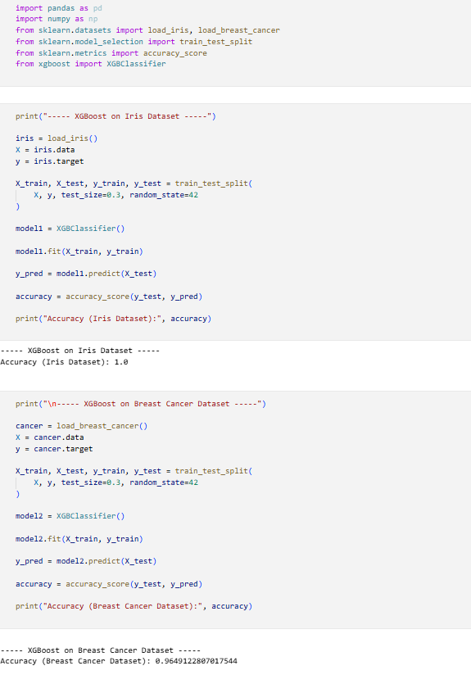
EXPERIMENT NO. 16

Student Name and Roll Number: Nishant Rajora 23csu220
Semester /Section: 6th Sem DS-A
Link to Code: https://github.com/NishantRajora/Machine-Learning
Date:
Faculty Signature:
Grade:

Objective(s):
- Study the basics of dimensionality reduction.
- Understand Self Organizing Maps
- Be able to build self-organizing maps.
Outcome:
Problem Statement:

Construct Self Organizing Maps on Iris dataset.
Background Study: A self-organizing map (SOM) or self-organizing feature map (SOFM) is a type of artificial neural network (ANN) that is trained using unsupervised learning to produce a low- dimensional (typically two-dimensional), discretized representation of the input space of the training samples, called a map, and is therefore a method to do dimensionality reduction.
Question Bank:
- Why do we need Self-Organizing Maps?
Self-Organizing Maps (SOM) are used to visualize and analyze high-dimensional data by mapping it into a lower-dimensional space, usually two dimensions. They help in clustering similar data points and discovering patterns in complex datasets.
- What is the difference between Feature Selection and Dimensionality Reduction?
Feature Selection selects the most important features from the original dataset without changing them.
Dimensionality Reduction reduces the number of features by transforming the original features into a smaller set of new features while preserving important information.
- What are Artificial Neural Networks?
Artificial Neural Networks (ANN) are machine learning models inspired by the structure of the human brain. They consist of interconnected nodes called neurons that process information and learn patterns from data. ANN is commonly used for tasks such as classification, prediction, and pattern recognition.

Student Work Area
Algorithm/Flowchart/Code/Sample Outputs

